# Mail Pharmacy Quantity Optimization - Bulk Up/Refill Consolidation

image2s Programs

Reminders

FAQs

Member Communication Sample

Related Documents

image2s **Description:** Information for the various Mail Pharmacy Quantity Optimization programs. The Home Delivery pharmacy (Caremark Mail Order Pharmacy) attempts to increase eligible < 84-day supply prescriptions to a 90-day supply. Each program operates differently per the notes below.

|  |
| --- |
| image2s Programs |

Refer to the table below:

|  |  |  |  |
| --- | --- | --- | --- |
| **Program** | **Line(s) of Business** | **Description** | |
| PLAN ASK 90 or 100 | Mostly Commercial, Some Medicare | * **Program Description:** Attempts to increase eligible less-than-84-day (< 84) supply maintenance to a 90-day supply prior to the first prescription fill * **Pharmacies Targeted:** Caremark Mail Order Pharmacy only * **Program Intent:** Promote improvement to members’ medication adherence. * **Clients:** Client opt-in is required. Clients authorize the mail pharmacy to increase eligible prescriptions to a 90-day supply without member consent. Prescribers or pharmacists review the drug for suitability to increase to 90-day supply. Some Med D clients request prescriptions to be increased to 100-day supply (Plan Ask 100). Verify client participation in the Client Information Form (CIF). * **Member Cost Share:** The copay for a three-month supply is generally less than getting three, one-month supplies. * **Eligible Drugs:** Certain low-cost, maintenance medications that are clinically appropriate for 90-day supply increments. Eligible prescriptions are identified by the formation of plan exception conflict. * **Excluded Drugs:** Classes are the following, but not limited to: Non-maintenance medications, short-term use medications, Class II controlled substances, topicals, erectile dysfunction medications, migraine medications and medications managed through the [Custom Care Mail (CCM) (039323)](https://thesource.cvshealth.com/nuxeo/thesource/#!/view?docid=4aede8ce-52ef-4266-8c5f-ac8ed8cd1342). * **Member Communication:** Members receive a letter communicating the increase to 90-day supply in their **first fill** shipment. Refer to Member Communication Sample. * **Member Opt-Out Requests:** If a member requests to opt out, contact the Senior Team to process the request. | |
| MED D MAIL 90-DAY OPTIMIZATION | Medicare Only | * **Program Description:** After first fill of < 84-day supply, program attempts to increase eligible < 84-day supply maintenance scripts to 90-day supply. * **Pharmacies Targeted:** Caremark Mail Order Pharmacy Only. * **Intended Members:** Intended for Medicare members only. * **Program Intent:** Promote improvement to members’ medication adherence for no cost medications. * **Eligible Prescriptions:** $0 member cost share on Medicare plans that have a $0 deductible and can be filled in 90-day supply increments (2024 only). * **Aetna** **members:** All $0 member cost share drugs are eligible, including Stars drugs. Stars drugs are eligible. * **Non-Aetna** **members:** All $0 member cost share drugs are eligible, except Stars drugs. If Stars drug, see Extended Days Supply Program. * **Clients:** Client opt-in to this program is required. Client that are opted into this program authorize the mail pharmacy to increase eligible prescriptions to 90-day supply without member consent since there should be no change in cost share (i.e., the cost share remains $0) when their prescription is increased to a 90 day supply. Verify client participation in the CIF. * **Excluded drugs:** Drug classes are the following, but not limited to non-maintenance medications, short-term use medications, Class II controlled substances, topicals, erectile dysfunction medications, migraine medications, medications managed through the [Custom Care Mail (CCM) program (039323)](https://thesource.cvshealth.com/nuxeo/thesource/#!/view?docid=4aede8ce-52ef-4266-8c5f-ac8ed8cd1342) and GLP-1 medications (**Examples:**  Mounjaro, Wegovy, etcetera). * **Non-Aetna Medicare Clients:** Stars drugs are excluded. Prescriptions covered by Low Income Subsidy (LICS) programs are not eligible * **Low Income Subsidy Claims:** Claims that are covered by low-income subsidy are eligible for this program. Please note that some members may disenroll from this program and may have out-of-pocket costs for their refills. * **Member Communication:** Members receive a letter communicating the increase to 90-day supply in their **next refill** shipment. Refer to Member Communication Sample. * **Member Opt-Out Requests:** If a member requests to opt out, contact the Senior Team to process the request. | |
| MAIL BULK UP | Medicare and Commercial | * **Program Description:** Allows members to request a 90-day supply for their <84-day supply maintenance prescription at mail. * **Pharmacies targeted:** Caremark Mail Order Pharmacy Only. * **Eligible Drugs:** Certain low-cost, maintenance medications that are clinically appropriate for 90-day supply increments. Eligible prescriptions are identified by the formation of plan exception conflict. * **Clients:** Client opt-in is required. Verify client participation in the CIF. | |
| EXTENDED DAYS SUPPLY PROGRAM | Medicare only | * **Program Description:** After first fill of < 84-day supply of a Stars drug, program attempts to increase eligible < 84-day supply Stars drug scripts to 90-day supply by sending fax request to prescriber. * **Pharmacies:** This program applies to eligible drugs filled at any pharmacy in the Caremark network, including the mail pharmacy. * **Clients:**  See list of clients that are opted in and pay for this service: | |
| **Level 0 ID** | **Level 0 Client Name** |
| S-3181 | HMSA |
| S-2014 | JOHNS HOPKINS |
| S-1560 | CAREFIRST MED D |
| S-51699 | SHARP MEDICARE |
| S-2291 | WMAHP |
| ACC-01 | MGBHP |
| S-2683 | BCBSMA |
| S-HPP | HEALTHPARTNERSPLANS |
| S-468 | CARELONRX |
| S-10296 | MOLINA MED D |

Top of the Document

|  |
| --- |
| Reminders |

Always check the CIF to determine if the client will allow a bulk up request.

image2s The Mail Pharmacy Quantity Optimization program is limited to:

* Members that are set up with a flat dollar copay structure with no percentage, co-insurance, or tiered co-pays.
* When requested, clients with a percentage copay or tiered copay based on days’ supply structure can be added to the Quantity Optimization program.
* The PBM will automatically optimize or try to optimize prescriptions which form a Plan Exception(s) ASK 90 DAYS SUPPLY conflict. If aPlan Exception(s) conflict **did NOT form**, then the prescription did not meet all the criteria for quantity optimization and will be filled as written.
* Targeted drug categories considered maintenance medications that do not impact clinical programs.
* Excluded drug classes are the following, but not limited to non-maintenance medications, short-term use medications, Class II controlled substances, topicals, erectile dysfunction medications, migraine medications and medications managed through the CCM program.

**Note:** If the member’s prescription was not bulked up and they are requesting the remainder of the 90-day supply, refer to [PeopleSafe – Bulk Up Rules CCR (030449)](https://thesource.cvshealth.com/nuxeo/thesource/#!/view?docid=e92bf2fd-2808-48f6-bb6d-fd22f0077735) or [Compass – Courtesy Retranslation Support Task (Bulk Up, Downsizing an Rx, and Variable Fill Requests)](https://thesource.cvshealth.com/nuxeo/thesource/#!/view?docid=a11f9225-37ee-4af0-83bf-7d492b2006cf).

Top of the Document

|  |
| --- |
| FAQs |

Use as needed:

|  |  |  |
| --- | --- | --- |
| **#** | **Question** | **Answer** |
| **1** | **Can a CCM client participate in both CCM and Bulk Up?** | image2s Yes, a client can participate in more than one program. |
| **2** | **If an order contains a combination of CCM and bulk up drugs, does the order go to both CCM and Bulk up?** | Yes |
| **3** | **Are all non-CCM clients participating in the bulk up program?** | The determination if a client participates in the program is not dependent upon CCM, but it is dependent on the client co-payment structure.   * If a client has a % co-payment (i.e., coinsurance) or tiered co-payment based on days’ supply, they are **excluded** from the program. Otherwise, all other clients are included. * The reason CCM comes into play is more on the target drug list and why some categories are excluded from the program (specifically Proton Pump Inhibitors <PPIs>). * When requested, clients with a percentage copay or tiered copay based on days’ supply structure can be added to the Quantity Optimization program. |

Top of the Document

|  |
| --- |
| Member Communication Sample |

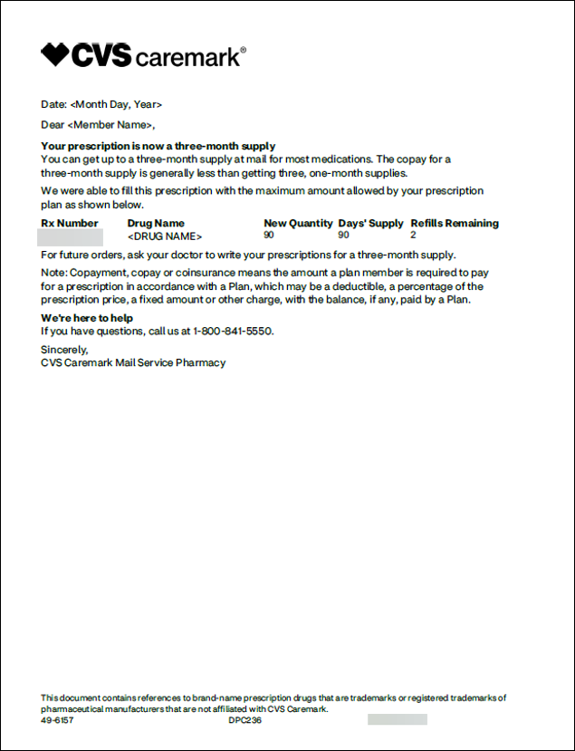

Top of the Document

|  |
| --- |
| Related Documents |

[Customer Care Abbreviations and Definitions (017428)](https://thesource.cvshealth.com/nuxeo/thesource/#!/view?docid=c1f1028b-e42c-4b4f-a4cf-cc0b42c91606)

**Parent Document:** [Customer Care Internal and External Call Handling (CALL-0049)](https://policy.corp.cvscaremark.com/pnp/faces/DocRenderer?documentId=CALL-0049)

Top of the Document

Not to Be Reproduced or Disclosed to Others without Prior Written Approval

**ELECTRONIC DATA = OFFICIAL VERSION / PAPER COPY = INFORMATIONAL ONLY**